**SURVIVAL ANALYSIS OF DIABETES**

CHAPTER-1

1.1 Introduction:

Diabetes is one of the deadliest diseases in the world. It is not only a disease but also a creator of different kinds of diseases like heart attack, blindness, kidney diseases, etc. The normal identifying process is that patients need to visit a diagnostic centre consult their doctor, and sit tight for a day or more to get their reports. Moreover, every time they want to get their diagnosis report, they have to waste their money in vain.

But with the rise of Machine Learning approaches we have the ability to find a solution to this issue, we have developed a system using data mining which has the ability to predict whether the patient has diabetes or not. Furthermore, predicting the disease early leads to treating the patients before it becomes critical.

The aim of this research is to develop a system which can predict the diabetic risk level of a patient with a higher accuracy. This research has focused on developing a system based on three classification methods namely, Decision Tree, Naïve Bayes, and Support Vector Machine algorithms.

* [**Type 1** diabetes](https://www.medicalnewstoday.com/info/diabetes/type1diabetes.php) usually appears first in children and adolescents, but it can occur in older people, too. The immune system attacks the pancreatic beta cells so that they can no longer produce [insulin](https://www.medicalnewstoday.com/info/diabetes/whatisinsulin.php) There is no way to prevent type 1 diabetes, and it is often hereditary. Around [5percent](https://www.cdc.gov/diabetes/basics/type1.html) of people with [diabetes](https://www.medicalnewstoday.com/info/diabetes/) have type 1, according to the Centre’s for Disease Control and Prevention (CDC).
* [**Type 2** diabetes](https://www.medicalnewstoday.com/info/diabetes/type2diabetes.php) is more likely to appear as people age, but many children are now starting to develop it. In this type, the pancreas produces insulin, but the body cannot use it effectively. Lifestyle factors appear to play a role in its development. According to the CDC, around [90–95 percent](https://www.cdc.gov/diabetes/basics/quick-facts.html) of people with diabetes have this type.
  1. **Objectives of research:**
* Differentiate between the pathophysiology of T1D and T2D.
* Distinguish between DKA and HHS.
* Explain why blood glucose levels should be less than 200 mg/dl before invasive dental treatment.
* Describe several strategies for stabilizing blood glucose levels for dental patients.
* Define normoglycemia in a way that a patient will understand.
* State the three psychological factors that have been identified with successful patient education outcomes.
* Name the two most important risk factors that are associated with increased susceptibility to periodontal disease.
* Identify the various environmental factors that impact periodontal disease associated with diabetes.
* Provide recommendations to a patient with diabetes following a dental procedure that may impact their ability to eat.
* Describe specific guidelines that dental professionals can recommend to patients following dental procedures that affect blood glucose control and/or eating ability.
* Define metabolic abnormalities related to diabetes.
  1. Problem Statement:

Diabetes is a chronic disease that affects millions of people worldwide. Uncontrolled cases can cause blindness, kidney failure, heart disease and other serious conditions. Before diabetes is diagnosed, there is a period where blood sugar levels are high but not high enough to be diagnosed as diabetes. This is known as prediabetes. Both types of diabetes can lead to complications, such as cardiovascular disease, kidney disease, vision loss, neurological conditions, and damage to blood vessels and organs.

It's estimated that up to 70% of people with prediabetes go on to develop type 2 diabetes. Fortunately, progressing from prediabetes to diabetes isn't inevitable.

### *Decision Tree Algorithm:*

Decision-Tree is a tree structure which has the form of a flowchart. It can be used as a method for classification and prediction with a representation using nodes and internodes. Root and internal nodes are the test cases. Leaf nodes considered as class variables. In order to classify a new item, it creates a decision tree based on the attribute values of the available training data set. Every node of the tree is generated by calculating the highest information gain for all attributes. If any attribute gives an unambiguous end result, the branch of that attribute will be terminated and then the target value is assigned to it. The following diagram shows a sample decision tree.

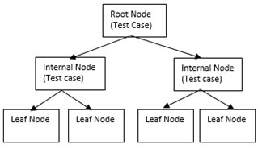

Although there are certain factors you can't change — such as your genes, age or past behaviours — there are many actions you can take to reduce the risk of diabetes.

### Make a commitment to managing your diabetes

### Don't smoke

### Keep your blood pressure and cholesterol under control

### Schedule regular physicals and eye exams

### Keep your vaccines up to date

### Take care of your teeth

### Pay attention to your feet

### Consider a daily aspirin

### Don’t drink alcohol

### Don’t stress more

* 1. Industrial profile:

“Digital health” refers to the convergence of health care and technology. In diabetes, it is defined specifically by connected devices gathering data, by software and apps making those data useful, and by the emergence of new care models that use technology to improve the outcomes of a chronic disease. Digital health per se is not new, but driven by the ubiquity of mobile devices and data, it can equip providers with better information, make patients’ lives simpler, and offer payers lower costs and better results. The possibilities are significant, but the results are far from guaranteed. The digital health field has seen tremendous growth in recent years.

This growth speaks to the potential of digital health, which has, perhaps prematurely, been characterized as the next “elixir” for health care. Yet, there is some basis to these high expectations. After all, digital solutions can help with many large and complex problems in diabetes: too many patients, too few providers, infrequent contact with health care providers (HCPs), inconsistent data, increased spending, and outcomes that are not improving at a satisfactory rate.

**Can Digital Health Solutions Help to Address Some of These Challenges?**

The remainder of this article explores how digital health could affect the future of diabetes care. In the following discussion, we have broken down digital health products and services into six categories:

 1) Cloud-connected glucose monitoring systems,

2) data management platforms,

3) telehealth services,

4) type 2 diabetes digital prevention programs,

5) mobile apps, and

6) social media.

These categories do not constitute an exhaustive list, but we do believe they have potential to address the previously described challenges.

CHAPTER 2

Review of literature

2.1 ABSTRACT

Diabetes mellitus has been a deadly and widespread disease majorly in Africa and Asia. A number of approaches have been employed in diagnosing this disease to provide awareness to patients who may have such. Several research works have been publishes and presented to look into a management system for its diagnosis.

Few reviews have been centred on this systematically and thoroughly, systematically capturing the entire crucial elements such as diabetes type addressed; control recommendation considered, main contributions and approach strengths. This have brought about the lack of sufficiently good context of operation. In this paper, we carried out a systematic review of existing literature concerning diabetes diagnosis management system in so as to present a summarized evidence regarding the issue and background for positioning new research activities appropriately.

KEY WORDS: Diabetes mellitus, Chronic disease, Diagnosis, Treatment, Glucose

2.2 PROJECT EXPLAINATION:

Diabetes mellitus is a metabolic disorder of multiple characterized by chronic hyper glycemia with disturbances of carbohydrate, fat, and protein metabolism resulting from defects in insulin secretion, insulin action. Characteristic clinical features of the disease include glycosuria, polyuria, and glycosuria. Weight loss in diabetes mellitus also occurs due to an increased breakdown and reduced synthesis of proteins. In the absence of insulin in acute conditions, diabetic ketoacidosis results and can lead to stupor, coma, and death. There is currently a large body of supporting literature which states that setting performance goals has a positive effect on individuals and groups, particularly in the workplace. Identity theories have been used to examine organizational behaviour in the workplace by studying group cohesion, decision making, work motivation and performance, leadership, turnover and mergers. One such theory, social identity theory, examines when and why individuals identify with, and identify it as a part of social groups. Few years now, some papers have centred on diabetes diagnosis system based on only one section in the paper/article and there are few which have carried out a review of diagnosis type addressed, control recommendations is core. After carrying out preliminary searches aimed at both identifying systematic reviews and assessing the volume of relevant studies that are relevant, there is therefore there is sufficiently good context to operate in Diabetes.

Information Extraction The information that were extracted from the studies contained techniques, methods, steps, strategies or any initiatives that were employed in the establishment of diabetes mellitus diagnosis management. The information forms that were defined for carrying out this systematic review is made up of study identification, motivation, methodology, results, strengths and weaknesses. The consideration in the extraction of methodology is focused on the diabetes mellitus type addressed, techniques employed and recommendation consideration. The consideration in terms of results of the approach is based on diabetes type addressed and recommendation approach of tackling the disease.

**CHAPTER 3**

**3.1 Data Collection:**

The aim of this study was to assess the completeness of data collection of patients with diabetes in a large sample of family Data collection is electronic, minimal and fits into the practice workflow to minimize participation burden and maximize clinical value.

We extracted the data on all the patients with diabetes from the electronic health records of 270 family physicians in 2006 and 2009. We reported the percentage of patients with data recorded for 12 indicators of performance derived from the National Institute for Clinical Excellence diabetes guidelines. Secondarily, we assessed quality of care using the Q-score (the lower the score, the greater the risk of cardiovascular events.

Patients with diabetes were 18,507 in 2006 and 20,744 in 2009, and the percentage of patients registered as having diabetes was 4.9% and 5.4% of the total population, respectively (p < 0.001). Data collection improved for all the indicators between 2006 and 2009 but the performance was still low at the end of the study period: patients with no data recorded were 42% in 2006 and 32% in 2009, while patients with data recorded for ≥5 indicators were 9% in 2006 and 17% in 2009. The Q-score improved (mean ± SD, 20.7 ± 3.0 in 2006 vs 21.3 ± 3.6 in 2009, p < 0.001) but most patients were at increased risk of cardiovascular events in both years (Q-score ≤ 20).

[Data collection of patients with diabetes in family medicine_ a study in north-eastern Italy.html](Data%20collection%20of%20patients%20with%20diabetes%20in%20family%20medicine_%20a%20study%20in%20north-eastern%20Italy.html)

**CHAPTER 4**

**Methodology**

4.1 Exploratory Data Analysis

**Procedure:**

* Load previous datasets to the system.
* Data pre-processing has done using integrating WEKA tool.
* Following operations are performed on the dataset after that

a. Replace Missing values.

         b. Normalization of values.

* User input data to the system in order to diagnose whether he has the disease or not.
* Build three models using J48 Decision Tree, Naïve Bayes, and SMO Support Vector Machine Algorithms and train the data set.
* Test the dataset using three models.
* Get the evaluation results.
* Get the predicted voting from all classifiers and gives the diagnostic result.

**4.2 Figures and tables**

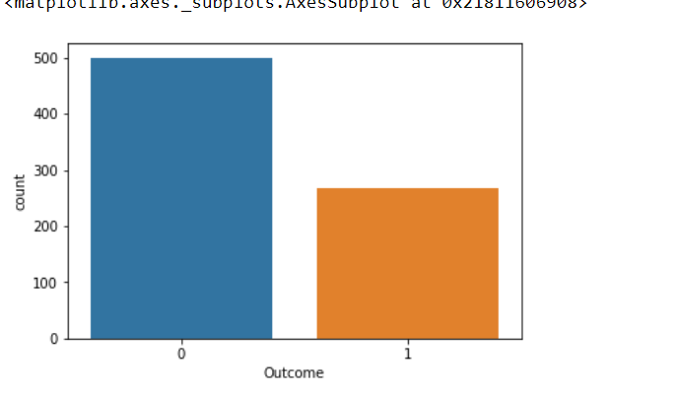

From the given dataset, we conclude that 500 people having diabetes and 268 are not having the diabetes.

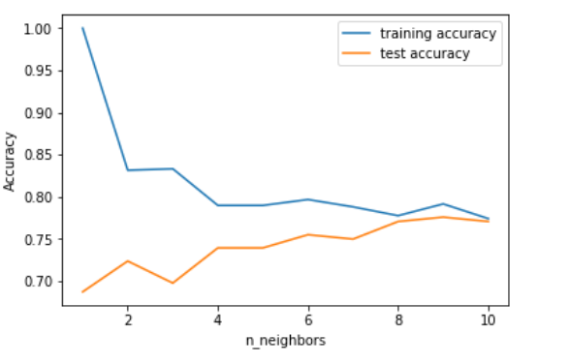

To determine which of the K instances in the training dataset are most similar to a new input a distance measure is useds.

4.3 Statistical Techniques and Data Visualization:

Data visualization is the presentation of data in a pictorial or graphical format. It enables decision makers to see analytics presented visually, so they can grasp difficult concepts or identify new patterns. Because of the way the human brain processes information, using charts or graphs to visualize large amounts of complex data is easier than poring over spreadsheets or reports. Data visualization is a quick, easy way to convey concepts in a universal manner – and you can experiment with different scenarios by making slight adjustments.

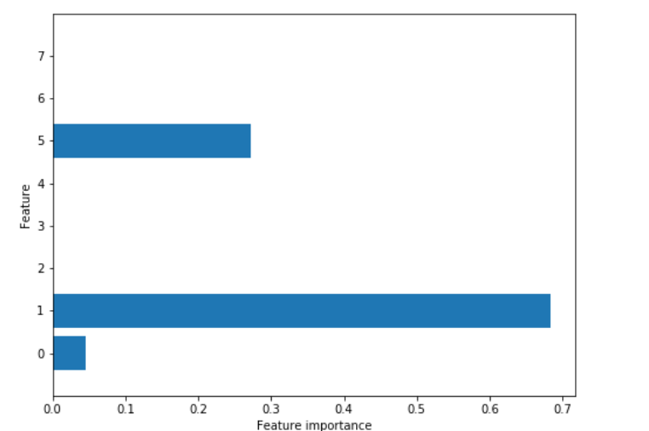

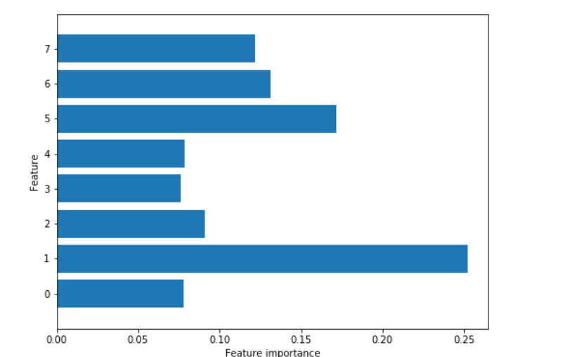

**4.4 Data Modelling using Supervised ML techniques:**

## What Are Decision Trees?

Simply put, a decision tree is a tree in which each branch node represents a choice between a number of alternatives and each leaf node represents a decision.

It is a type of supervised learning algorithm (with a predefined target variable) that is mostly used in classification problems and works for both categorical and continuous input and output variables. It is one of the most widely used and practical methods for inductive inference. (Inductive inference is the process of reaching a general conclusion from specific examples.)

Decision trees learn and train themselves from given examples and predict for unseen circumstances. 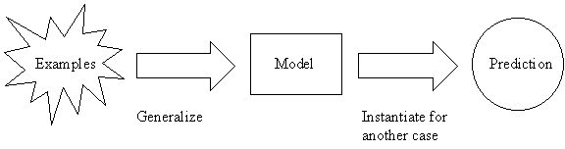

A graphical representation of a sample decision tree could be:

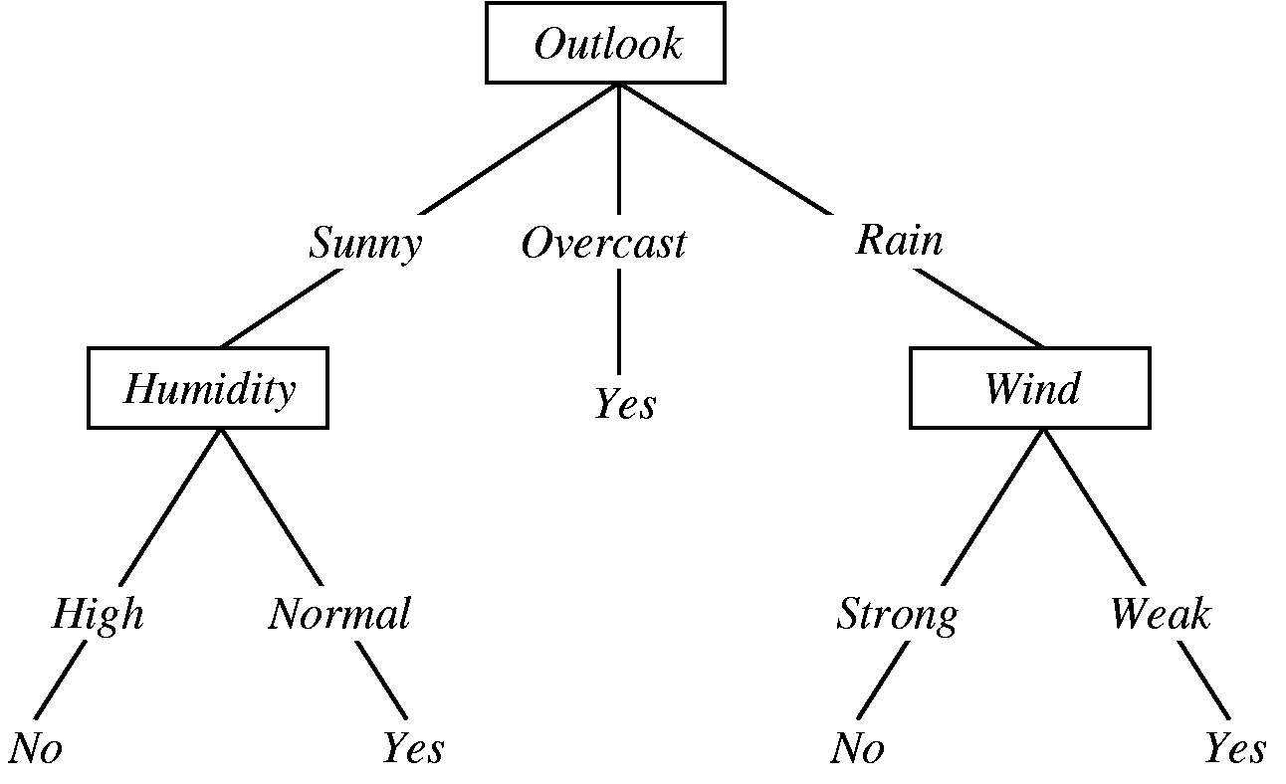

**4.5 Findings and Suggestion**:

The [symptoms of diabetes](https://health.usnews.com/health-news/patient-advice/articles/2015/10/01/do-i-have-diabetes) can be very mild. Although symptoms are similar for both Type 1 and Type 2 diabetes, Type 2 diabetes symptoms are especially hard to pinpoint. "In many patients with Type 2 diabetes, the disease progresses slowly, and they may not realize that they have developed it without screening. There are millions of patients who have diabetes who are not aware that they have it,"

In fact, of the 78 million people in the U.S. who have diabetes in india.

So what are the most common symptoms of diabetes?

**You have to urinate more often.**This is because your kidneys are working harder to process extra sugar in your urine.

**You feel more thirsty than usual.**As you urinate more, you feel more dehydrated – and that makes you want to drink more liquids. Some people also feel hungrier than usual.

**You have increased urinary tract, yeast or vaginal infections.** Sometimes, OB-GYNs help to diagnose diabetes based on an increased frequency of these infections, says Lucille Hughes, a certified diabetes educator and director of diabetes education at [South Nassau Communities Hospital](https://health.usnews.com/best-hospitals/area/ny/south-nassau-communities-hospital-6213735) in Oceanside, New York. Changes to the body's immune system put those with diabetes at higher risk for these infections, according to the [National Kidney Foundation](http://www.kidney.org/sites/default/files/uti.pdf).

**You experience unintentional weight loss.** While many people want to lose weight, the weight loss that occurs when you have [uncontrolled diabetes](https://health.usnews.com/wellness/articles/2017-02-17/weight-loss-surgery-may-top-medication-alone-for-hard-to-control-diabetes) is not a healthy weight loss. It happens because your body can't properly use insulin to help process glucose, a sugar found in food, for fuel. So your body starts to process fat and muscle for fuel, says [Susan M. De Abate](https://www.sentara.com/woodbridge-virginia/aboutus/news/experts/susan-de-abate.aspx), a nurse, certified diabetes educator and team coordinator of the diabetes education program at [Sentara Virginia Beach General Hospital](https://health.usnews.com/best-hospitals/area/va/sentara-virginia-beach-general-hospital-6341162).

**You experience occasional blurred vision.**Uncontrolled diabetes can lead to a condition called [diabetic retinopathy](https://health.usnews.com/health-news/patient-advice/articles/2016-04-12/eye-health-insights-for-patients-with-diabetes), which affects your vision. Eye doctors sometimes play a role in helping to diagnose diabetes because of the vision symptoms a patient experience.

* **Lose extra weight.**
* [**Check your blood sugar**](https://www.webmd.com/diabetes/monitoring-blood-sugar-avoiding-diabetes-complications)**level at least twice a day**
* **Get**[**A1c**](https://www.webmd.com/diabetes/manage-type-2-insulin-16/video-lower-your-a1c)[**blood**](https://www.webmd.com/a-to-z-guides/rm-quiz-blood-basics)**tests** to find out your average blood sugar for the past 2 to 3 months. Most people with [type 2 diabetes](https://diabetes.webmd.com/guide/diabetes_symptoms_types) should aim for an A1c of 7% or lower. Ask your doctor how often you need to get an [A1c test](https://www.webmd.com/diabetes/guide/glycated-hemoglobin-test-hba1c).
* **Track your carbohydrates.**
* **Control your**[**blood pressure**](https://www.webmd.com/hypertension-high-blood-pressure/guide/diastolic-and-systolic-blood-pressure-know-your-numbers)**,**[**cholesterol**](https://www.webmd.com/cholesterol-management/default.htm)**, and**[**triglyceride levels**](https://www.webmd.com/cholesterol-management/lowering-triglyceride-levels)
* Regular [exercise](https://www.webmd.com/fitness-exercise/default.htm) can help you reach or maintain a healthy weight.
* [**Manage stress**](https://www.webmd.com/webmd/consumer_assets/controlled_content/healthwise/special/stress_management-ways_to_relieve_stress_special_ta4381.xml)**.**
* [blood sugar levels](https://www.webmd.com/webmd/consumer_assets/controlled_content/healthwise/medicaltest/blood_glucose_medicaltest_hw8252.xml).
* [kidney](https://www.webmd.com/kidney-stones/picture-of-the-kidneys) damage, [nerve damage](https://www.webmd.com/brain/nerve-pain-and-nerve-damage-symptoms-and-causes), and [heart disease](https://www.webmd.com/heart-disease/ss/slideshow-visual-guide-to-heart-disease) to be safe.

**Result and Discussion**

The results of systematic review give a summary of the studies qualities per discovered initiative. The main contributions, in terms of the diabetes diagnosis management approach, diabetes mellitus type considered and limitations by each selected initiative Physical control recommendation: This has to do with if the initiative considered recommending physical activities such as bodily routine exercises to tackle the diabetes disease in a patient. Nutritional control recommendation: This is based on any nutritional measure such as type of meal, fruits or drink to be taken to treat a diabetes sit mutation. Drug prescription recommendation: This is concerned with the consideration of returning a feedback on what type of drug a diabetic patient who has been diagnose should take. The type of initiative that considers any of these will be labelled as C while those that did not consider any of these will be stated as NC in the table.

**Conclusion:**

This course covered the annual review for people with diabetes. You have seen that even if someone feels they are in good health, they may still have risk factors that could increase the chances of getting diabetes-related complications. It is important to create a plan, which is agreed between the person with diabetes and the health professional, to show what actions need to be taken to reduce risk factors or maintain low risk.

**Awareness:**

The diabetes annual review is an opportunity to check for factors that will increase a person's risk of developing diabetes complications, so they can address them before damage occurs. The idea is very much that ‘prevention is better than cure’. It is also an opportunity for the person with diabetes to get feedback on how well they are doing (and recognition if they are struggling with aspects of their condition).

The study recommends the following approaches to the local people to avoid diabetes, the dreaded killer.

1. Say no to alcohol, if you are a drinker.

2. Quit smoking, if you are a smoker.

3. Try to avoid cholesterol enriched diet.

4. Go for vegetarian diet, try to avoid meat.

5. Enrich your physical activities.

6. People with family history of diabetes should be more alert to evade from the onset of diabetes.

7. If you are diabetic go for routine medical check-up

8. Always maintain your body fit.

9. Always keep your mind and soul happy.

10. Be a good follower, not a preacher of good ideal.

We can say “No” to diabetes by proper awareness, routine healthcare check-ups, healthy lifestyles and avoiding metabolic syndrome to make a diabetes free world. Studying this course will have built on your knowledge of diabetes and diabetes care systems, and the personal impact of having diabetes, as well as helped you to think about underlying risk factors for complications.

CHAPTER-7

References:

By listening classes of our trainer and some references taken from google.